Updating LT-103 firmware
July 2014

Starting from July 2014, Microtestmachines Co. proposes a utility software for testing and upgrading a firmware in control electronics for LT-103 Langmuir–Blodgett trough. It consists of a specialized program uploading firmware into the controller and a binary file (a set of binary files) that is the firmware to be uploaded.

How to use the utility?
Place the software executive file load.exe in one folder with other libraries

Qt5Core.dll
Qt5SerialPort.dll
Qt5Widgets.dll
Qt5Gui.dll
icudt51.dll
icuin51.dll
icuuc51.dll
libstdc++-6.dll
libgcc_s_dw2-1.dll
libwinpthread-1.dll

as well as subfolder platforms\ containing additional libraries

qwindows.dll
qoffscreen.dll
qminimal.dll

and binary file(s) (e.g. LT103_test.bin, LB_trough.bin)

Connect LT-103 control electronic unit with the host PC from which it will be controlled via USB cable. Turn on the control electronic unit (host PC is run as well) and wait a little till initial load of the unit finishes.
Then follow the instructions below.
1. Start the software executive file load.exe. The utility panel will be displayed on host PC:

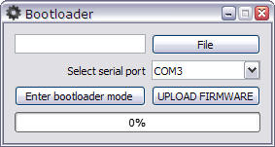

2. Load binary file with appropriate firmware. For first time running it is recommended to load test firmware to check the hardware configuration, namely, use file LT103_test.bin. To load file, press button File and choose necessary file in standard dialogue, for example:

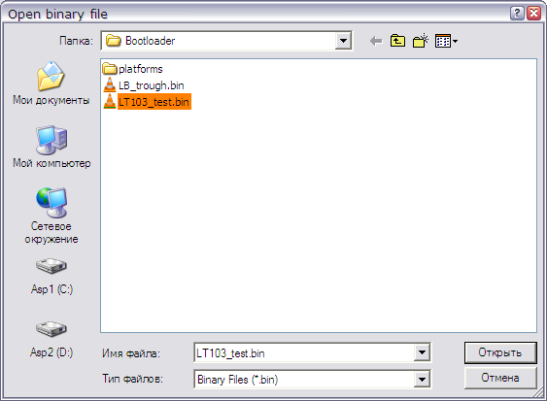

3. After loading necessary binary file, select appropriate serial port from the list ( COM# ) to provide connection between host PC and LT-103 control electronic unit, for example:

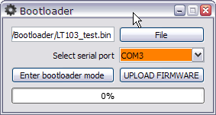
Usually, the bootloader program detects correct serial port automatically and proposes it in the list by default.

4. Press button Enter bootloader mode to prepare the control electronic unit to the firmware upload. The utility will give notification ‘Device is in bootloader mode’ Display on control electronic unit will notify about switching to bootloader mode in lower line, for example:

Tension = 0.1
-=Bootloader=-

5. Press button UPLOAD FIRMWARE and wait till uploading finishes what will be announced ‘Firmware loaded!’.
6. Exit the ultiliy (press X button in right corner of the panel).

Please note, if you first uploaded test firmware, display will show following information:

L:1 R:1 U:1 D:1
-=Bootloader=-

Upper line describes configuration of limit switches installed in the LB trough and according to it you are to select corresponding edition of the firmware. After detecting the configuration, you may omit pressing button Enter bootloader mode and simply choose appropriate firmware edition and start the uploading.

Thank you for cooperation.

