Preparing the foil for the deposition in Roll-to-Roll device

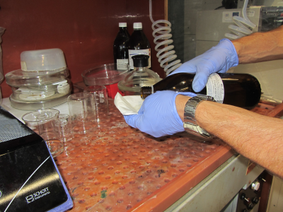  Spill chloroform on the wipe  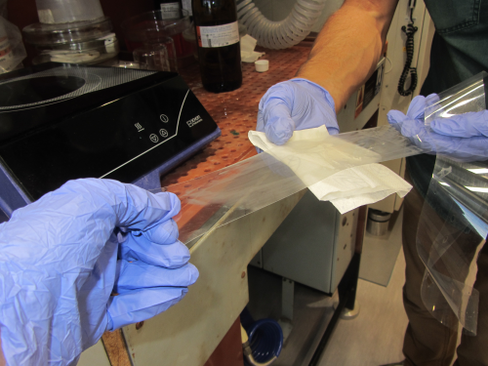  Draw the foil and wipe it from both sides with tissue (moistened with chloroform) section by section starting from one end  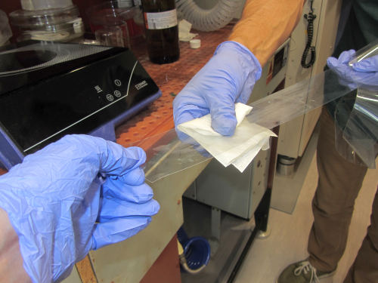  Wipe the foil from both sides. | Prepare portion of the PET foil. The length of the tape should be bigger than 1 m. Additionally will be used  - chloroform (not chromatography clean),  - tissue (without piles),  - distilled water for washing,  - source of nitrogen for blowing drops off and drying,  - gloves for hand protection,  - fume hood to provide ventilation.  If manual cleaning will be realized, it is recommended to do it with two persons. Alternatively, you can gradually clean the foil portion by cleaning it while winding from one spool to another.

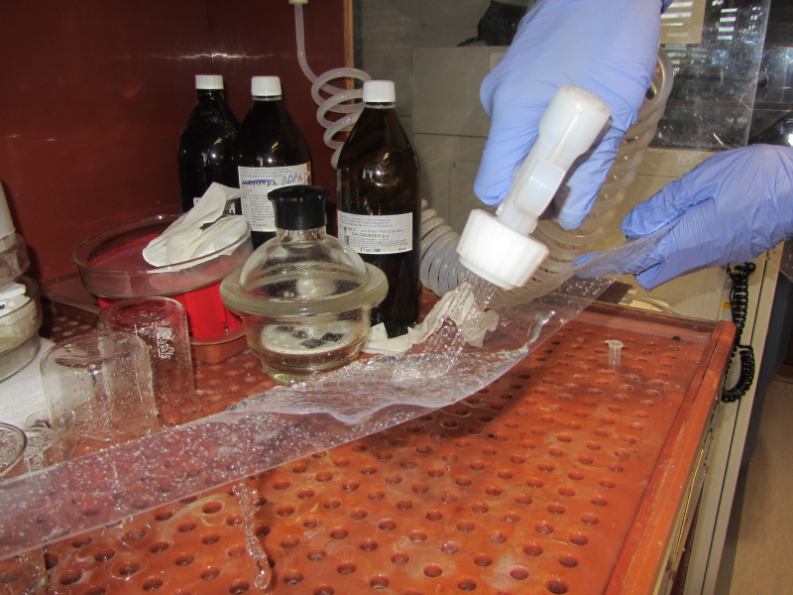  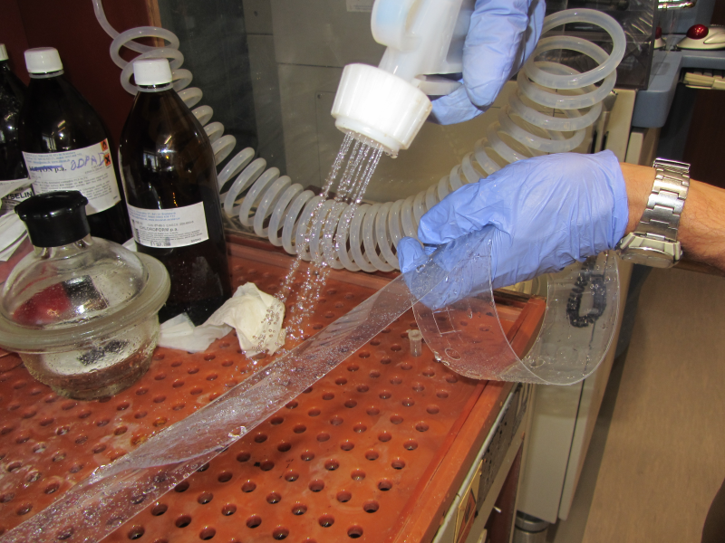 | After wiping the foil with chloroform, wash its both sides with distilled water.  It is recommended to draw the foil and wash the contaminants and dirt off with water jet. Gradually wind the washed portion of the foil till the whole foil will be cleaned. If previous cleaning with chloroform was performed carefully, isolated water drops will remain on the foil.
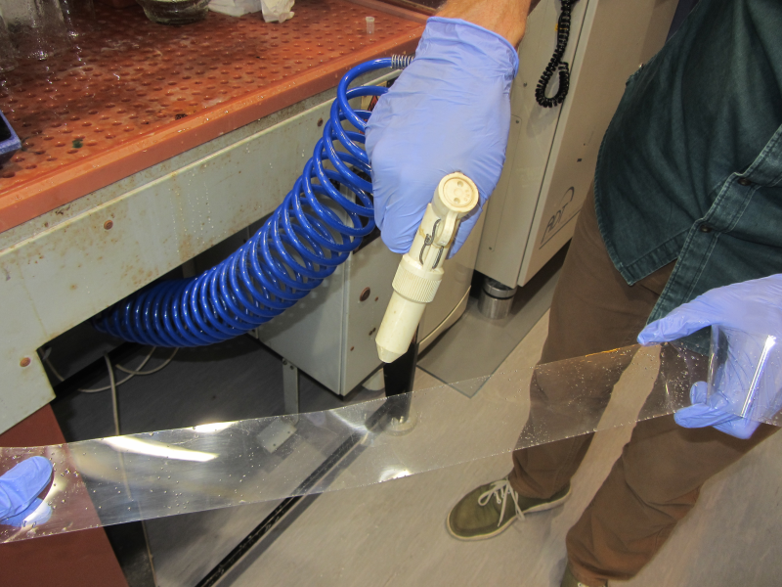 | After washing the foil with distilled water it is necessary to dry it with nitrogen stream.  Practically, disperse the water drops off the foil sides with N₂ stream or dry the surfaces during that.

